All Important links
Links

Video links from PPT

HR session video links:
- Let there be change
https://mediaexchange.accenture.com/media/t/1_xmcvvyhi
- Workday generation navigation.
https://mediaexchange.accenture.com/media/t/1_6mqolt1h
- Wow From Home, ATCI! - A message by Mahesh
https://mediaexchange.accenture.com/media/t/1_5w76wz9d
- The new myLearning ... inspired by you
https://mediaexchange.accenture.com/media/t/0_yjgh0ku3
​
Dipa
https://askdipa.accenture.com

Accenture Security Operations Center (ASOC)
+91 80 4106 2762 ( Click option 2 in the menu )
Call ASOC for support in case of an accident, a serious illness, a natural calamity or a security threat.
India.ehs@accenture.com
Mail India.EHS for any non-COVID-19 related medical assistance.
​
​

To download Wysa,
Option 1: SMS “<ACN ATCI>” to 92932 92932**
Option 2: Scan the QR Code You can also visit this pagefor more details


​

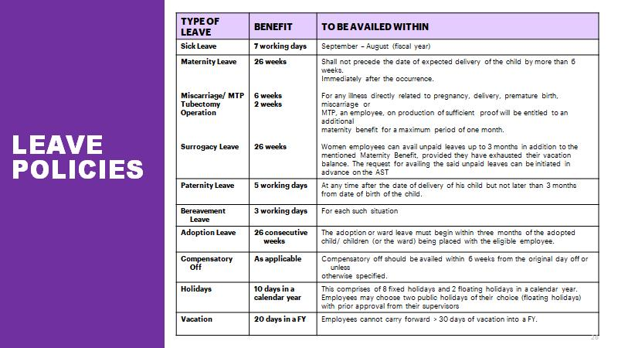
New Joiner portal
https://in.accenture.com/india/njo/#

For employee information correction.
NAME/ID Display CHANGE
https://directory.accenture.com/NameChange/

Vidal insurance
1860-425-0258
Important Portal Links :
- Policies https://policies.accenture.com/
- Transport https://india.etransport.accenture.com
- ATCI Home https://ts.accenture.com/sites/ATCIHome/Pages/index.aspx/
- Year One at Accenture https://in.accenture.com/yearone/
- Myte https://myte.accenture.com
- Scheduling https://myscheduling.accenture.com/
- Learning https://mylearning.accenture.com
- Performance https://performance.accenture.com
- AST https://ast.accenture.com
- Support https://support.accenture.com
- Dipa https://askdipa.accenture.com
- Holiday calendar https://in.accenture.com/india/?site=1&blog=548&p=60494&referrer=digest
- Workday https://wd3.myworkday.com/accenture/d/home.htmld
- Allsec Link- https://smartpay.allsectech.com/accenturelogin
- AON (Insurance portal) - https://accenture.tbs.aon.com/
- Insurance tool- https://accenture.tbs.aon.com/
- Insurance Team contact details- Get in touch with the Benefits Contact Center via AccentureIndiaBenefits@aon.com / 0008000402898 between 12 p.m. and 9 p.m.
- Payroll Virtual ID- SessionQA1@Accenture.com ; SessionQA2@Accenture.com
- Path to raise an PR- (Human Resources and Payroll > Payroll > Ask Payroll > Salary)
- PF contact- (Support.accenture.com>Human Resources and Payroll > Payroll > Ask Payroll > Provident Fund)
- Insurance contact- (Support.accenture.com>Human Resources and Payroll > Payroll > Ask Payroll > Insurance)
- Non Competence denial form.
Onboarding.doc.atci@accenture.com

Accenture Home page https://portal.accenture.com
(All Accenture Links) https://portal.accenture.com/#/all_accenture_links
AllSec Site & PF Forms Allsectech https://smartpay.allsectech.com/accenturelogin/
My TE Time & Expense https://myte.accenture.com/
Information Security Advocate https://in.accenture.com/protectingaccenture/dashboard/
MySurvey https://mysurveys.accenture.com/manage
Accenture Benifities Portal https://accenture.tbs.aon.com/homenew
https://support.accenture.com

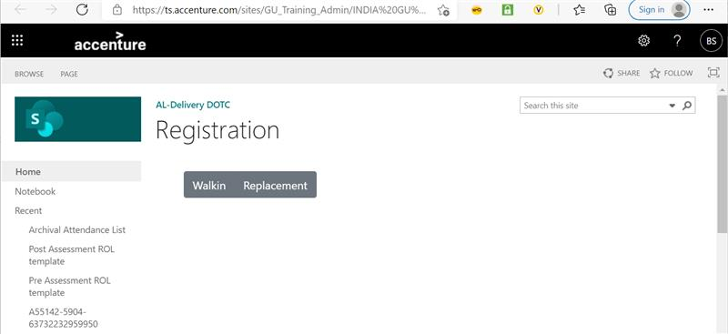

PF transfer
Step 1
Login to Unified portal (member interface) by using your credentials i.e., UAN number and password.
Step 2
After login, click on ‘One Member – One EPF Account (Transfer Request)’ under Online Service
Step 3
Verify personal information and PF account for present employment:
Step 4
PF account details of previous employment would appear on clicking on ‘Get details’ below.
Step 5
You have the option of choosing either your previous employer or current employer for attesting the claim form based on the availability of authorized signatory holding DSC. Choose either of the employers and provide member id/UAN:
Step 6
In the next step, click on ‘Get OTP’ to receive OTP to UAN registered mobile number and enter the OTP and click on submit.
The employer will digitally approve your EPF transfer request by accessing employer interface of the unified portal. Fill up Form 13 with details including PF number from both previous and current employer and download the transfer claim (pdf format). Submit the physical signed copy of the online PF transfer claim form to the selected employer within a period of 10 days.
​
VACCINE Reimbursement.

Claim the Vaccine reimbursement by selecting expense type as ‘Other Expense’ > Select ‘Testing & Vaccinations (TESTVAC)’ from the ‘Assignment’ dropdown.
Under “Type” select ‘Testing & Vaccinations’. Type “Vaccine reimbursement” in the description. Please ensure that you upload a copy of the receipt for the payment made .
Portal Name Link : Policies https://policies.accenture.com/ Transport https://india.etransport.accenture.com ATCI Home https://ts.accenture.com/sites/ATCIHome/Pages/index.aspx/ Year One at Accenture https://in.accenture.com/yearone/ Myte https://myte.accenture.com Scheduling https://myscheduling.accenture.com/ Allsec https://smartpay.allsectech.com/Accenturelogin/SmartLogic/memberlogin.aspx Learning https://mylearning.accenture.com Performance https://performance.accenture.com AST https://ast.accenture.com Support https://support.accenture.com Dipa https://askdipa.accenture.com Workday https://wd3.myworkday.com/accenture/d/home.htmld
Payroll Virtual ID- SessionQA1@Accenture.com ; SessionQA2@Accenture.com
​

Hey folks! Thanks a lot for attending the session, hope you all found it useful. I am sharing all the important links of the videos/other content covered today. Please do leverage the same:
1. Allsec Link- https://smartpay.allsectech.com/accenturelogin
2. AON (Insurance portal) - https://accenture.tbs.aon.com/
3. Insurance tool- https://accenture.tbs.aon.com/
4. Kotak Team mail ID- kotakhelpdesk.accenture@kotak.com
5. Insurance Team contact details- Get in touch with the Benefits Contact Center via AccentureIndiaBenefits@aon.com / 0008000402898 between 12 p.m. and 9 p.m.
Contact details: 18004258885 08028004100 SMS: 9740048866
6. Payroll Virtual ID- SessionQA1@Accenture.com ; SessionQA2@Accenture.com
7. Path to raise an PR- (Human Resources and Payroll > Payroll > Ask Payroll > Salary)
8. PF contact- (Support.accenture.com>Human Resources and Payroll > Payroll > Ask Payroll > Provident Fund)
List of Banks Accenture is tied up with:
- SBI
- HDFC
- ICICI
- CITI
- KOTAK
- STANDARD CHARTERED
- AXIS
- IDFC
- DBS
- HSBC
How can you enroll?
- Log in to Your Rewards and click Changes on the Choose your Benefits tile.
- Click Manage Dependents and add or modify your dependents.
- Go to the insurance policy you want to enroll your dependents in and click Change.
- You will be able to see the coverage options with the respective premium for the chosen dependents.
- Choose the coverage amount and click Continue.
- Select the payment frequency method by clicking Change again to specify if you want to pay in lump sum or three installments.
- Confirm Enrollment once done.
​

Refer to the policy terms and conditions for more details or get in touch with the Benefits Contact Center via AccentureIndiaBenefits@aon.com / 0008000402898 between 10 a.m. and 9 p.m., Monday to Friday.
​
Follow the below path to open the WFH Reimbursement booking page:
Allsec Smartpay -> Reimbursement -> WFH Assistance Reimbursement Booking.
Step 1: Read the declaration statement. Click on ‘Yes’ to proceed Step 2: Input all the required purchase details Step 3: In case you are filing for reimbursement for multiple items, click on ‘Add New’ and repeat Step 2 Step 4: Once you have added product details for all the items, click on ‘Save’. Post this the ‘Upload’ button gets enabled. Step 5: Click on ‘Upload’ à ‘Choose’ to select the invoice/s and proof of payment from your system. Click on ‘Upload’ to upload the chosen file. ‘File uploaded successfully’ message appears. If multiple items are captured in one invoice, just attach the invoice once. Step 6: Click on ‘Submit’ to submit all your claims. Step 7: Confirmation box appears, click on ‘Yes’. ‘Submit was successful’ message appears, user is redirected to non-editable page updated with all details.
Please note: Once you click ‘Submit’, you will not be able to file for any new claims in that month’s window and would need to wait for the next month’s window to open. The claim window would be open between 1st to 10th of every month during the reimbursement window.

For PRAN conversion:
You need drop an email to ICICI Bank POC with the following details for conversion of your PRAN from Individual to Corporate Model (No physical documents / forms):-
• Employee Code (8 Digit SAP ID)
• Employee Name
• Date of Birth
• Date of Joining
• Date of Retirement (60 years from the DOB)
• Existing PRAN account number

Below are the details of the location ICICI Bank POC’s.

Bengaluru - ankur.jain@icicibank.com
Chennai - babu.tc@icicibank.com
NCR - arjun.maurya@icicibank.com
Mumbai - manoj.pawar@icicibank.com
Pune - anil.raut@icicibank.com
Kolkata - chandan.kumar5@icicibank.com
Hyderabad - deepa.bharti@icicibank.com

Information Security
- Security Moments – Quick Reference Guide
2. Complete the Information Security Advocate trainings under the IS Advocate program. Also visit https://mylearning.accenture.com for other mandatory trainings.
3. Validate your home network security settings (Wi-Fi encryption, router password).
4. Save these contacts to your phone:
- ASOC: India +91 80 4106 2762 & Global +1-202-728-0645
5. Software usage guidelines - https://in.accenture.com/legal/nssr/
6. Master link for all Security-related things: Protecting Accenture

Other links:
- Technology Support Or Use “MyTechHelp” app by searching for it in MS Teams
- Accenture portal – Homepage for everything at Accenture
- https://in.accenture.com/mobiledevicesandtelephony/mobile-productivity/

Working Securely From Home - https://in.accenture.com/protectingaccenture/stay-secure/working-securely-from-home/
Workstation Compliance - https://in.accenture.com/protectingaccenture/workstationcompliance/
Social Engineering - https://in.accenture.com/protectingaccenture/data-security/social-engineering/
Top IS Behaviours - https://in.accenture.com/protectingaccenture/top-is-behaviors/
Report an Information Security Breach -https://in.accenture.com/protectingaccenture/report-an-information-security-breach/
IS Advocate Dashboard - https://go.accenture.com/isadvocate
Check your Phishing results - https://ts.accenture.com/sites/Information_Security3/SocialEngineering/SEPersonalStatus.aspx
ASOC India Local Number:
+91 80 4106 2762 To report online: https://asoc.accenture.com
Data classsification, store & share information: https://in.accenture.com/protectingaccenture/select-a-tool/
Security Movements: https://in.accenture.com/protectingaccenture/security-moments-list/#atwork
Safe Downloads: https://in.accenture.com/protectingaccenture/safe-downloads/
Vishing & Smishing Attacks: https://in.accenture.com/protectingaccenture/vishing-and-smishing-attacks/

NSSR request: https://support.accenture.com | India.NSSR@accenture.com | https://support.accenture.com/support_portal/?id=iframe_catalog_request&sys_id=aed365d1dbbd07003cacfb051d96199a

Protecting Accenture: https://in.accenture.com/protectingaccenture/

Software Accenture: https://support.accenture.com/support_portal?id=acn_sac&spa=1&page=softwares&category=top-downloads

Hackerland Series: https://mediaexchange.accenture.com/media/t/1_9vborsr2

Password manager - https://in.accenture.com/protectingaccenture/stay-secure/storing-information/password-managers/

IT incident - https://techselfsupport.accenture.com/

Mobile device enrollment - https://in.accenture.com/mobiledevicesandtelephony/mobile-productivity/

CTSD contact details:
MyTechHelp BOT or dial primary and secondary Bengaluru CTSD Direct Inward Dialing (DID) numbers +91 80 40775555 and +91 80 66875555 (BDC employees)
MyTechHelp BOT or dial Primary and Secondary Mumbai DID numbers +91 22 61861000 or +91 22 41161000 (Other locations in India)

• Issue with login credentials, password and OTP Issue mainly faced while logging through External email Ids (Gmail, Yahoo, etc):
• Reach out to the below contacts as per your location
Bengaluru Users – 080 4077 5555 / 080 6687 5555 option 9-1-9
Rest of India Users - 022 6186 1000 / 022 4116 1000 option 9-1-9

